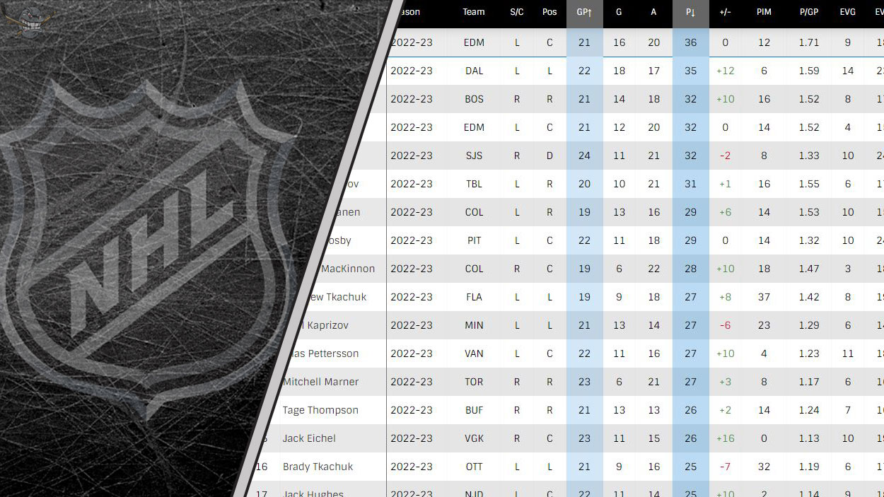  Frozen Insights:  UNVEILING THE DYNAMICS OF NHL PLAYER DATA STATISTICS | Abstract  Welcome to my project, "Frozen Insights: Unveiling the Dynamics of NHL Player Data Statistics." In this project, I dive into the intricate world of National Hockey League (NHL) player statistics. From goals and assists to time on ice and advanced analytics, I aim to uncover patterns and insights that define player performance beyond the surface. Whether you're a hockey enthusiast, fantasy league player, or data science enthusiast, join me as I navigate the statistical landscape, offering a comprehensive look at the numbers that tell the story of NHL players and their impact on the game. "Frozen Insights" is not just a statistical analysis but a journey into the heart of the sport, celebrating the exceptional athletes who shape the NHL.  Christopher Ward  Probability and Applied Statistics

Suppose you wanted to know the average number of points scored by a player in an NHL season.
The top point scorer in the 2022/23 NHL Season, Connor McDavid, scored 153 points. This makes the average of 23 points seems extremely low. That’s because many players only play get to play a few games. For example, players get injured forcing clubs to pull up minor league players to play a limited number of games. So, what if we filter the data to only the top 100 point-scorers that season? What about only players that played 41+ games (half the regular season)?
